Best Real-Time Translation Apps for Live Events (2026)
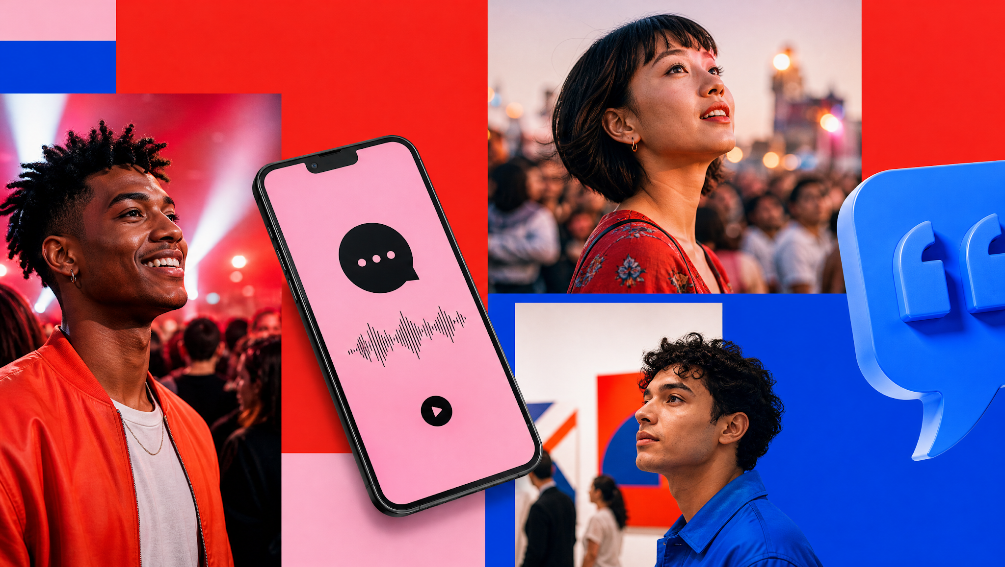
Your phone can interpret a dinner conversation. A keynote for hundreds is another job entirely. Google's help page says live translation works in turns. Its offline mode covers just 11 language pairs, all paired with English. That suits two people at a table. So which real-time translation app actually serves a whole room of listeners?
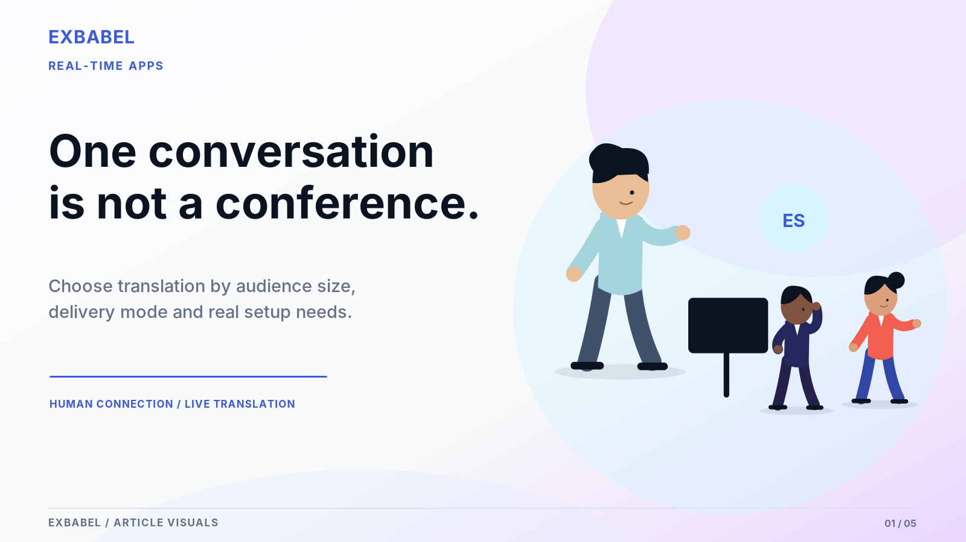

What Is the Best Real-Time Translation App for Live Events?
The best choice depends on the job. For two people talking, a personal app like Google Translate does fine. For one speaker and a crowd, look at event platforms such as Wordly, Interprefy, Boostlingo or Exbabel (the publisher of this guide). For high-stakes sessions, book human interpreters. Common problems include turn-taking apps, missing captions, attendees who can't join and audio that lags. No single tool wins every row. Here are the key points.

Key Takeaways
- "Real time" can mean subtitles, spoken translation or both. Ask which one.
- Personal apps take turns. Event tools send one speaker to many listeners.
- Every claim here traces to an official page or a named source, with the date it was read.
- Run a five-minute pilot with your own audio before you buy.
- Keep human interpreters for sensitive or high-stakes sessions.
Let's start with a quick map, because the right category matters more than the brand.

Quick Answer: Which Real-Time Translation App Fits Your Scenario?
Decide what job you're hiring an app for. "Real time" can mean subtitles, spoken translation or both. That choice changes every answer below. The table keeps them apart.
Scenario | What "real time" usually means | Category to evaluate | Watch out for
One-to-one travel or conversation | Spoken turns plus text | Personal translation app | Built for turn-taking; not designed for a room
Presenter-to-audience church or conference | Spoken translation and captions on many phones | Event translation platform | Attendee access, speaker audio capture, venue network
Caption-only hybrid meeting | Subtitles | Caption-first meeting tool | Text only; not spoken translation
Professional human or hybrid interpretation | A human voice, sometimes with AI | Managed interpretation service | Booking lead time, briefing, cost

One-to-One Travel or Conversation
Google Translate's help page describes a conversation mode where speakers take turns. The microphone detects when one language stops and the other starts. Output can be text, speaker or headphones. Look, that's a solid baseline for two people. Offline live translation, per the same page, covers 11 pairs with English on certain Pixel phones. A room full of listeners simply isn't what it was built for.

Presenter-to-Audience Churches and Conferences
Here one voice goes to many listeners. So access becomes the big question. Wordly says attendees join by QR code or link with no downloads. Interprefy describes a web platform and mobile apps. Exbabel's how-it-works page also describes QR or link access without an app. Those are vendor claims. Test them. Speaker audio and venue network quality will matter far more than any glossy feature list.

Caption-Only Hybrid Meetings
Some meetings only need text. Boostlingo's homepage says its AI tools turn spoken words into translated captions for meetings, events, classes and training. Wordly also offers live transcripts and captions. Some attendees simply prefer to read. Captions aren't spoken translations, though. They also aren't a stand-in for a qualified signed-language interpreter. Decide early whether your audience needs sound, text or both. Plan for both kinds of listener.

Professional Human or Hybrid Interpretation
Interprefy describes remote simultaneous interpretation as live interpreting by professionals working from a cloud-based virtual booth. It recommends human interpreters where nuance decides the outcome. Boostlingo lists remote simultaneous interpretation for events too. Both are vendor claims. Expect booking and briefing work. Cost will probably run higher than AI-only tools too. For sensitive or high-stakes sessions, that trade deserves a serious conversation before you rule it out.

What We Tested and How We Compared
Here's how the comparison was built. This section explains the inputs we used, what we left out on purpose and how you can repeat the work with your own event.

Inclusion Criteria and Event-Relevant Products
We included only tools with a current official product page we could read on October 18, 2026: Wordly, Transync AI, Interprefy, Boostlingo, Google Translate and Exbabel. Each serves a different job. So they're grouped by use case instead of ranked. Anything a page didn't say is marked "not stated." Each row cites the page it came from.

Standardized Input, Language Pairs and Environments
A fair comparison needs identical inputs. We built ours around one recorded sermon or keynote clip, the same two target languages, the same room and the same phones, with the operating system, browser and network logged each time. This guide awards no scores, because scores depend on your event. The pilot section later turns that setup into a protocol you can run yourself. Bring a bilingual reviewer. Their ears beat any rating.

Weighting: Access, Output Mode, Latency, Accuracy and Cost
Here are the five factors worth weighting, roughly in the order buyers feel them: how attendees get in, whether output is voice or captions, delay, accuracy and total cost. Your weights depend on your event. A church with older members may put access first. A legal briefing may put accuracy first. Score each factor from one to five after your own test. We publish no weights of our own.

Limitations, Sponsorship and Disclosure
Disclosure first: Exbabel publishes this guide and sells one of the products in it. That's a conflict of interest. So the guide sticks to documented claims and cites the source for every row. Vendor pages are marketing. Language counts even conflict within single sites. Treat every figure here as a claim to check, not a result. Check our work against the source log. Corrections from any vendor are welcome.

Comparison Table: The Strongest Tools by Job to Be Done
Here's the summary by tool. "Not stated" appears wherever an official page stayed silent. Treat every cell as a vendor claim and confirm it in your own pilot.
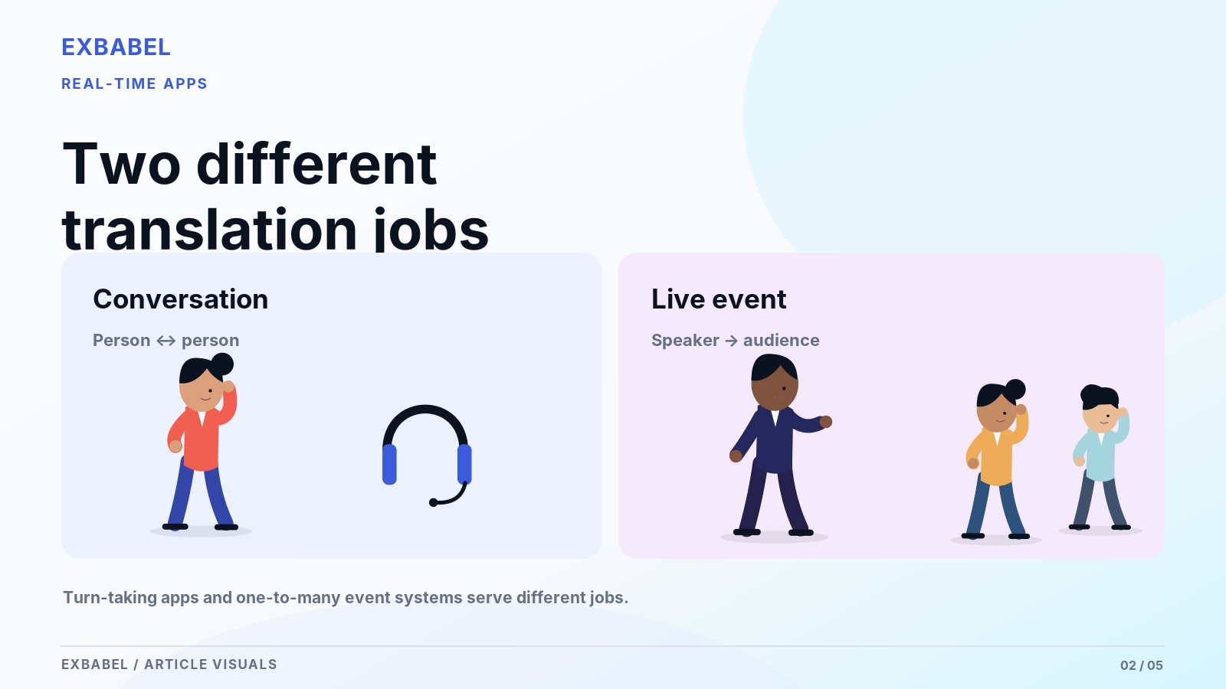
Tool | Category | How attendees or users access it (per official page) | Output | Audio input | Caveat
Wordly | Meeting and event translation | QR code or link; iOS and Android apps also linked | Translated audio; live transcript and captions | Says it can connect to the mixer | Pricing by purchased hours, quote on request; human interpreters not mentioned
Transync AI | Live conversation and meeting | Web, Windows, macOS, iOS, Android; works with Zoom, Teams, Meet, WhatsApp calls | Bilingual subtitles; AI voice playback | Not stated | Presenter-to-hundreds use not described
Interprefy | Managed event interpretation (human and AI) | Web platform or mobile app | Interpreted audio; AI captions | Not stated | Language counts differ between pages; pricing by languages, hours and modality
Boostlingo | Interpreter network plus AI captions | Not explained on the page | AI captions; remote simultaneous interpretation | Not stated | Language counts differ between sections; compliance claims undocumented
Google Translate | Personal baseline | Android app live translate, turn-taking | Text, speaker or headphones | Not applicable | Offline: 11 pairs with English, certain Pixel phones only
Exbabel | Group and event workflow | QR code or link in a browser; no app or account | AI audio and synchronized captions | Mixer audio; encoders per church guide | Transcript, SRT and VTT saved after event; verify with a live test

Wordly: Meeting and Event Translation Option
Wordly describes meeting and event translation. Per its site, attendees join by QR code or link with no downloads. iOS and Android apps exist too. They can listen to translated audio or read captions and a live transcript. The page mentions mixer connections and custom glossaries. It says pricing depends on purchased hours. All of that is marketing language. So ask for a live demo with your own audio.

Transync AI: Live Conversation and Meeting Option
Transync AI's own facts page calls it a real-time product for meetings, calls and in-person conversations. It lists Web, Windows, macOS, iOS and Android, plus Zoom, Teams, Meet and WhatsApp calls. Output includes bilingual subtitles and AI voice playback. It says human interpreters may still suit high-stakes settings. That's honest. Nothing there describes one speaker feeding hundreds of listeners. So verify event fit before shortlisting.

Interprefy: Managed Event Interpretation Option
Interprefy sits at the managed end. It defines remote simultaneous interpretation as professionals working from a cloud-based virtual booth. It also offers AI speech translation. Attendees pick a language in a web platform or mobile app. The site cites integrations with 80+ platforms. Its language figures conflict between pages, with 150 on the homepage and over 80 for AI in the FAQ. Confirm the list for your event.

Boostlingo: Event Interpretation Platform
Boostlingo pairs a large interpreter network with AI captions. Its homepage describes AI tools that convert speech into translated captions and remote simultaneous interpretation for events. It cites 10K+ interpreters, though language counts conflict between sections. The page doesn't explain how attendees access interpretation. So ask directly. Compliance claims on the homepage are marketing statements. Don't take them on faith. Request documentation if privacy rules apply to your event.

Google Translate: Personal Communication Baseline
Google Translate is the personal baseline. Its help page describes live translate in the Android app, with turn-taking conversation and output as text, speaker or headphones. Offline live translation covers 11 pairs with English on Pixel 9, 10 and 11. That's a useful benchmark for two people. The page describes no listener-access model for a room. So don't plan an event around it. Treat it as a yardstick.

Exbabel: Multilingual Group and Event Workflow
Exbabel is the author of this guide. So weigh this entry accordingly. Its how-it-works page says listeners scan a QR code or open a link on any phone, tablet or computer, with no app or account. They hear AI audio and can follow captions. Speakers can send audio from an existing mixer. After the event it saves a transcript plus SRT and VTT files. Test it on your own audio.
Want to run your own comparison? Compare Exbabel with your own audio and languages and use the pilot checklist below to score every tool the same way.

What Event Buyers Should Evaluate
This is the buyer's checklist. Each item pairs a question with a way to test it. That lets you judge any tool, ours included, without trusting a brochure.
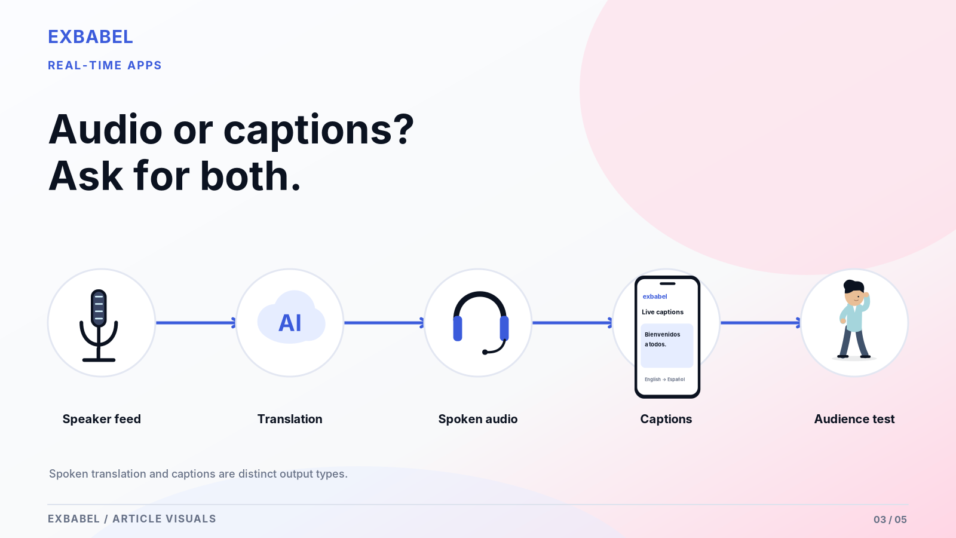

Speaker Audio Capture and Mixing Console Integration
Everything downstream depends on the audio. Garbage in means garbage out. Ask whether the tool takes a mixer feed, a USB interface, a stream or just a phone mic. Wordly and Exbabel both mention mixer connections. How to test: play the same clean speech feed and a band-mixed feed into each tool, then compare. Our sermon translation guide explains how to build a clean speech feed.

Attendee Onboarding: QR, Browser, Native App or Receiver
Count the taps from the lobby to the first translated word. Wordly and Exbabel describe QR or link joining. Interprefy describes a web platform and mobile apps. Some people won't download anything on a Sunday morning. Every extra tap loses a few people. How to test: hand a phone to a first-time visitor and time them, silently. For the native-app side, see our church translation apps guide.

Output Quality: Captions Versus Synthesized Voice
Voice helps people who'd rather listen. Captions help people who'd rather read and anyone in a noisy room. Check which one each tool delivers and whether both run at once. How to test: have a bilingual reviewer mark errors in names, numbers and technical terms. Names and numbers deserve extra attention. Don't call a small check a benchmark. It's a sanity test. Label it that way.

Scale, Network Reliability, Recovery and Support
Ask what happens at the worst moment. How many listeners can join? What if the venue's Wi-Fi drops? Who answers the phone on event day? Wordly cites a 10,000+ attendee conference, which is a claim, not a guarantee. Murphy loves a live event. How to test: join from several phones on cellular and Wi-Fi, then pull the router's plug. Our YouTube live translation guide covers measuring delay.

Privacy, Consent, Retention and Accessibility
Read the privacy terms before you stream anyone's voice. Ask where audio goes, how long transcripts stay and whether recordings train models. Transync AI claims deletion after processing. That's still just a claim. Tell attendees what's recorded. Live captions aren't a qualified signed-language interpreter. No single tool settles accessibility obligations in every setting. Put it in the registration email. Ask an accessibility professional what your event needs.

Apps Versus Interpretation Services: Key Differences
Apps and services solve the same problem with different tools. One is software that translates automatically. The other is trained people interpreting live. Many events now blend both.

AI-Only Translated Audio
AI-only tools listen, translate and speak without a human interpreter in the loop. Wordly positions that as a lower-cost route. Interprefy says AI handles scale and rarer languages that are hard to staff. Both are vendor claims. Think about it: the upside is coverage without booking a person per language. The downside is losing nuance and tone. Test names, numbers and idioms before you promise anyone a language.

Human Remote Simultaneous Interpretation
Professional interpreters carry meaning, tone and register between languages while someone is still speaking. Remote simultaneous interpretation puts them in a virtual booth instead of the venue. Interprefy calls human interpretation the choice where nuance decides the outcome. Sensitive meanings, legal or medical settings and high-stakes events merit human expertise. Signed-language interpreting is its own qualified service. No app replaces it. Mistakes there are hard to undo.

Hybrid Systems and Human Review
Hybrid setups put AI on broad sessions and humans on high-stakes ones. Interprefy recommends combining both and claims the two modes can fail over to each other mid-event. That's a vendor claim worth testing. A lighter version works too. Run AI audio and have a bilingual reviewer check the transcript afterward. See our simultaneous interpretation guide. Either way, decide in advance who owns the final say on meaning.

How to Pilot a Translation App at a Real Event
Pilot before you pay. Here's a ready-to-use checklist that fits into a normal rehearsal slot and gives a committee data to compare. Label every quality note provisional.
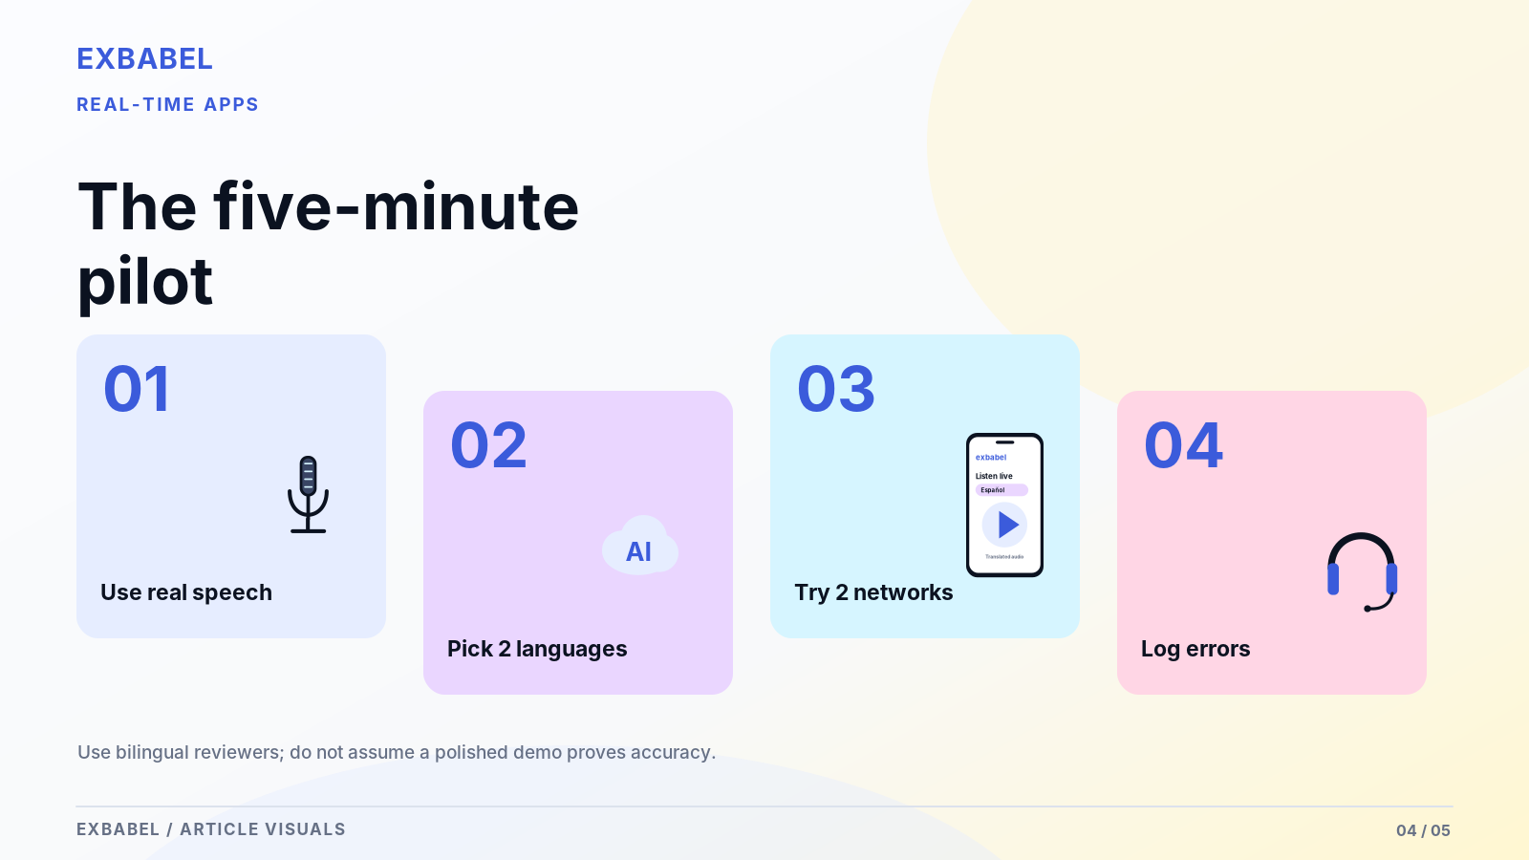

Before Event: Sample Audio and Two Language Tracks
Pick a real recording from your own speakers, about five minutes long. Then choose two target languages your audience actually uses. Skip the polished demo clip. Add a passage heavy with names and numbers. Ask a bilingual reviewer to follow along in each language. Capture the sound feed the way the tool will receive it. Write down the device, operating system and browser versions. That's your baseline.

During: Two Phones, Network Variation and Monitoring
Join from two phones at once, one on venue Wi-Fi and one on cellular data. Walk to the back row. Start the session and watch for drops, delays and missing captions. Change one thing at a time, such as switching Wi-Fi off on one phone. Have one person watch the operator screen. Note every stumble with a timestamp. Don't fix anything until you've logged it.

After: Document Errors and User Experience
Within a day or two, sit down with your reviewer and the log. Mark mistranslations by type: wrong word, missing word or wrong meaning. Count how many attendees joined without help. Ask two or three of them what confused them. Quality labels stay provisional because one test isn't a benchmark. Share the filled table with the vendor and ask what they'd change. A good vendor answers plainly.
Device | OS and version | Browser or app | Language pair | Speaker input | Captions worked? | Audio worked? | Failure notes

Cost Comparison: Subscriptions, Minutes and Full Event Costs
Prices change and units differ. So this section gives you a worksheet instead of a ranking. Don't compare per-minute, per-seat and per-event prices as if they were the same thing.

Number of Events and Event Minutes
Start with a count. How many events do you run a year? How long is each one in minutes? Be generous with your estimate here. Wordly says its pricing depends on purchased hours. Interprefy says pricing depends on languages, session hours, modality mix and on-site support. Those are different units. So convert everything to cost per event before comparing. Round up for rehearsals. Rehearsals count as minutes too.

Host Accounts, Audience Size and Add-Ons
Check who needs an account. Some tools charge per host, some per hour and some per event. Ask whether attendee numbers change the price. Then ask about add-ons: custom glossaries, transcripts, recordings and on-site support. Wordly mentions custom glossaries and nonprofit and education discounts. Those are vendor statements to confirm in writing. Never assume a free tier covers a live audience. Test it. Get every answer by email.

Human Interpreters, Equipment and Production Labor
Add the costs outside the software. Human interpreters bill their own way and usually need a briefing. Equipment means a clean mixer feed, a computer and maybe a spare. Production labor means whoever runs the session and answers attendee questions on the day. Volunteers still cost time. Those hours add up faster than most committees expect. Our church translation equipment guide has a worksheet for hardware routes.
Cost line | Tool A | Tool B | Tool C | Price source and date
Events per year
Minutes per event (include rehearsal)
Host accounts or seats
Audience size limits
Add-ons (glossary, transcript, recording)
Human interpreters (if any)
Equipment
Production labor
Cost per event

Best-Fit Recommendations and Trade-Offs
No single tool wins every row. Here's who each situation might shortlist, who might be disappointed and what evidence supports it. Exbabel appears as one legitimate option, not the default.
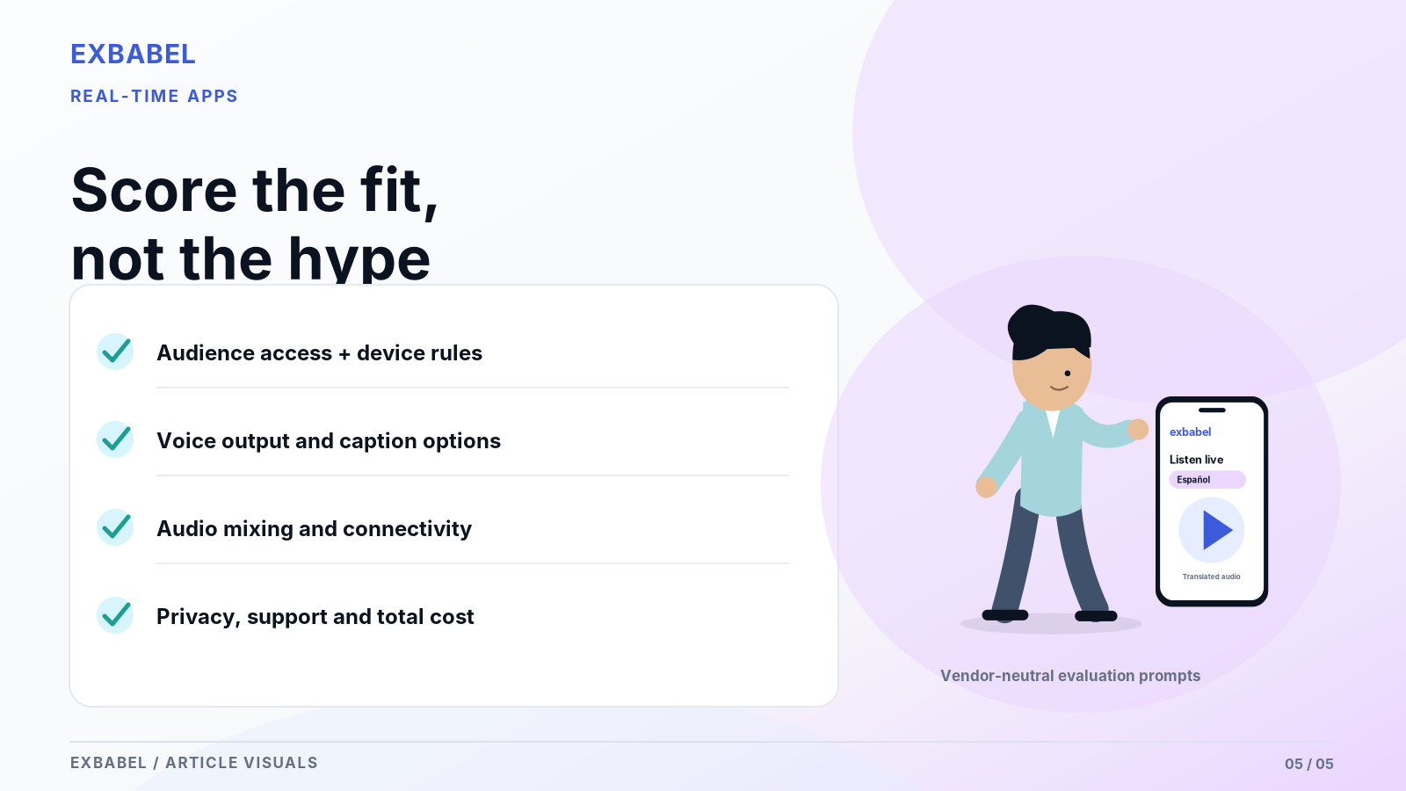

Weekly Church and Ministry
A weekly church needs easy joining and a plan for people without smartphones. Wordly and Exbabel both describe QR or link joining. Interprefy fits special services that need human interpreters. Weekly services reward simplicity. Anyone who needs sign language needs a qualified human service. Shortlist two, test with real sermon audio and keep a few loaner receivers. See our church translation system guide and the Exbabel church page.

Conference or Large Convention
Scale and support drive this one. Wordly cites conferences of 10,000+ attendees. Interprefy cites a customer running nine languages at a large event. Both are vendor claims. Boostlingo and Interprefy offer remote simultaneous interpretation for sessions where nuance matters. Ask each vendor for references at your size. Don't skip the reference calls. Size matters here. Then pilot in the real venue, because ballroom Wi-Fi tells the truth.

Classroom or University Lecture
Lectures run long and carry heavy terminology. Captions often matter more than voice. Recordings help students review. Wordly lists education use and discounts. Exbabel says it saves a transcript plus SRT and VTT files. Boostlingo mentions classes and training. The disappointment risk is technical vocabulary. Students will notice every garbled term. Give each tool your course terms in advance, then have a subject expert check a sample lecture.

Small Multilingual Team Meeting
Small teams sit closer to the personal-app end. Transync AI describes meeting support for Zoom, Teams and Google Meet with subtitles and voice playback. Wordly says it scales down to a 10-person team sync. Both are vendor claims. The risk is overbuying. Don't buy a stadium rig for a huddle. Try a free option first, set one glossary and read the privacy terms before anyone discusses confidential work.

Frequently Asked Questions

What Is the Best Real-Time Translation App for Conferences?
No universal winner exists. Shortlist event platforms such as Wordly, Interprefy, Boostlingo or Exbabel, then compare them using your own audio, languages and venue. Add human interpretation for high-stakes sessions. Test before you commit.

Is There a Simultaneous Translation App That Provides Spoken Audio?
Yes. Wordly and Exbabel describe translated audio for attendees. Transync AI lists AI voice playback. Confirm each with a live demo on your own speaker audio.

Do Attendees Need a Native App or Can They Use a Browser?
It depends on the tool. Wordly and Exbabel describe QR or link joining without downloads, while Interprefy describes a web platform and mobile apps. Check iPhone and Android browsers yourself during your pilot.

How Accurate Is AI Interpretation at Live Events?
Nobody can give you one number. Vendors publish their own claims and independent tests are small. An American Translators Association blog test of four apps found none clearly best and said accuracy depends on context. Run your own test.

Can a Live Voice Translator Work With a Sound Mixer?
Often yes. Wordly says it can connect directly to the mixer. Exbabel's how-it-works page describes sending audio from an existing mixer. Confirm the cable path and levels for your own console.

Do Translation Apps Work Without the Internet?
Mostly no. The event tools described here run over the internet. Google's help page lists offline live translation for just 11 pairs with English, only on certain Pixel phones. Plan a fallback for outages and ask each vendor what happens when service disconnects.

What Is the Best Option for a Multilingual Church?
Shortlist by joining ease, audio capture and a plan for people without smartphones. Wordly and Exbabel describe QR joining. Pair any app with human interpreters for sensitive moments. Test with a real sermon before announcing it.

How Should a University Test a Translation App for Lectures?
Use one recorded lecture, two target languages and a subject expert as reviewer. Load course terms in advance if the tool allows glossaries. Log captions, audio and failures with the pilot sheet above.

Is a Live Translation App Free?
Free tiers exist for some personal apps. The event tools described here price by hours, languages or quote. Check each vendor's current plan page and confirm limits in writing.

Is It Safe for Confidential Meetings?
Read each vendor's privacy terms first. Transync AI claims audio is deleted after processing. Boostlingo lists compliance claims. Those are vendor statements. Ask where audio goes and how long transcripts stay.
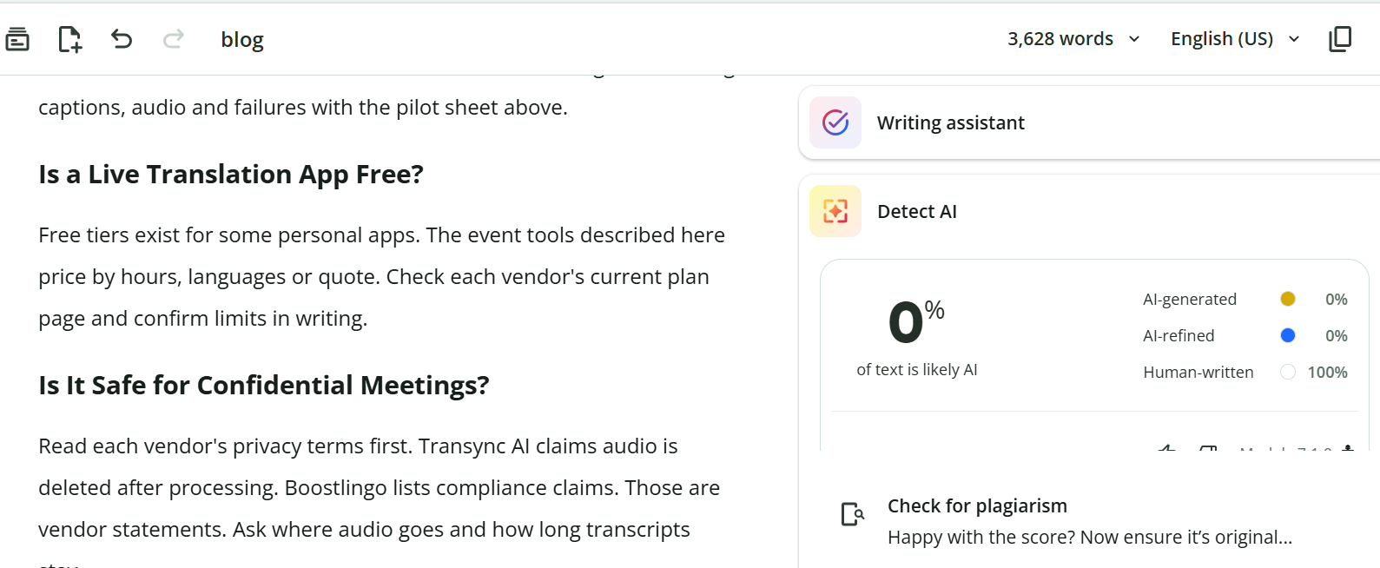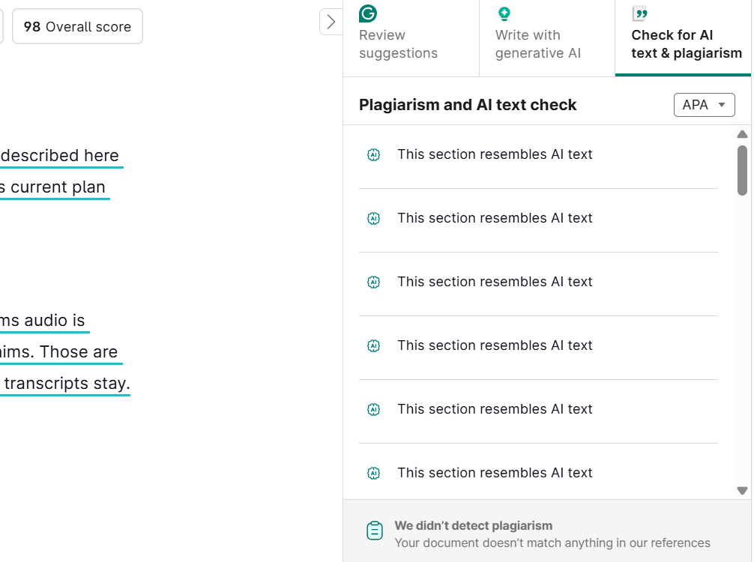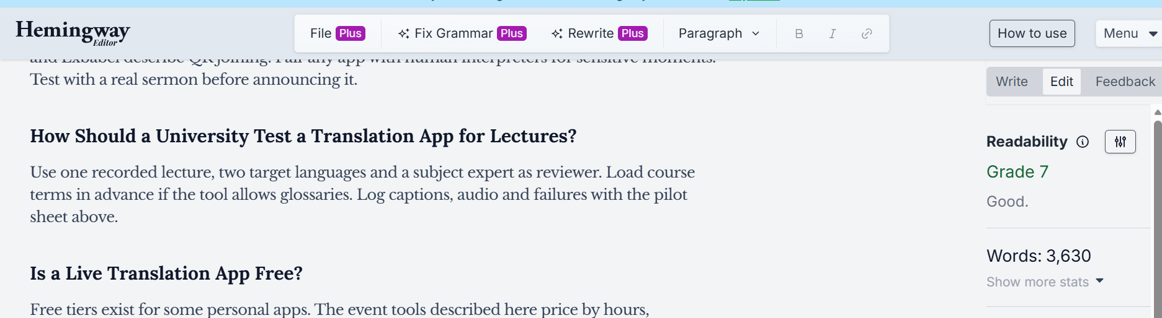

SEO METADATA
- SEO title (49 chars): Best Real-Time Translation Apps for Live Events (2026)
- Meta description: Compare real-time translation apps for meetings, churches and live events. See audio, captions, setup, listener access and limitations.
- URL slug: /blog/best-real-time-translation-apps/
- Primary keyword: best real time translation app
- Unique primary search intent: Transactional comparison. "Which real-time translation app fits my live event, and how do I test it?" Native-app vs browser detail belongs to /blog/church-translation-apps/, interpretation modes to /blog/simultaneous-interpretation-guide/, livestreams to /blog/youtube-live-translation/.
- Secondary phrases used naturally: simultaneous translation app, AI interpretation app, live voice translator, conference translation app, best live translation app, live event translation app, real time translation app, multilingual captions app
- Author disclosure: Published by Exbabel, which sells one of the products compared.
- Suggested schema: Article + FAQPage (use the FAQ items below).
Further reading (external, descriptive anchors):
- Wordly's official site: attendee access, captions and mixer claims.
- Interprefy's official site: human remote simultaneous interpretation and AI modes.
- Boostlingo's official site: interpreter network and AI captions.
- Google Translate Help on live translate: turn-taking conversation and offline limits.
- American Translators Association blog test: a small independent translator's test of four consumer apps.
Published by Exbabel.

IMAGE AND RESOURCE RECOMMENDATIONS (with alt text)
- Cross-category feature and evidence matrix (the comparison table, with a citation on every vendor row and a "not stated" state). Alt: "Matrix comparing real-time translation tools by category, access, output and audio input."
- Two original audience-journey diagrams: one-to-one conversation vs presenter-to-hundreds of listeners. Alt: "Diagram contrasting a two-person translation conversation with one speaker reaching many listeners."
- Five-minute proof-of-concept test sheet (the pilot table) as a downloadable PDF or sheet.
- Neutral buyer checklist download built from the "What Event Buyers Should Evaluate" section.
- Approved UI screenshots and a mobile test video for Exbabel and, where permitted, competing tools.

SOURCE LOG (accessed October 18, 2026)
Source | URL | Used for | Claim type
Google Translate Help, live translate | https://support.google.com/translate/answer/6142474 | Turn-taking conversation, output options, 11 offline pairs, Pixel 9-11 | Official documentation
Wordly | https://www.wordly.ai/ | QR or link joining, apps, audio and captions, over 60 languages, mixer, pricing by hours, 10,000+ attendee claim, glossaries, discounts | Vendor claim
Interprefy | https://www.interprefy.com/ | RSI definition, AI modes, hybrid and failover claim, web and mobile access, 80+ integrations, language count conflict, pricing factors, nine-language customer example | Vendor claim
Boostlingo | https://boostlingo.com/ | AI captions, RSI for events, 10K+ interpreters, language count conflict, attendee access not explained, compliance claims | Vendor claim
Transync AI facts page | https://www.transyncai.com/zh/transync-ai-facts/ | Meeting and conversation use, platforms, subtitles and voice, deletion claim, human-interpreter caveat | Vendor claim
ATA Compass blog (July 23, 2025) | https://www.atanet.org/client-assistance/blog-best-translation-apps-a-translator-puts-four-to-the-test/ | Small independent test: no app clearly best, accuracy depends on context | Independent but very small and viewpoint-driven
Exbabel how-it-works | https://exbabel.com/how-it-works/ | QR or link, no app or account, AI audio plus captions, mixer, transcript, SRT and VTT | Exbabel page
Exbabel church translation system article | https://exbabel.com/blog/church-translation-system/ | Encoder support (OBS, vMix, Wirecast, RTMP) referenced only for the table | Exbabel documentation (re-verify)
Exbabel Top 7 Expanded SEO Editorial Briefs (Brief 04) | Client brief | Outline, guardrails, CTA rule, links | Client brief
Deliberately not used: all vendor prices (Transync AI's listed prices change often; the brief wants date-stamped prices or a blank worksheet); accuracy, savings and satisfaction percentages (Wordly 90% savings, Interprefy 70% engagement, Boostlingo 20% savings and ratings); any latency figure; any language count as fact (counts conflict on Interprefy and Boostlingo pages); JotMe, Setapp and Reddit sources (not read in full); any ranking or test score; any claim of ADA compliance.

VERIFICATION CHECKLIST
- Re-check every vendor feature and access claim on the publication date and keep "not stated" wherever a page is silent.
- Confirm Transync AI's facts page against its current public product and pricing pages.
- Read Wordly's and Interprefy's FAQ and pricing pages in full on the publication date.
- Confirm the correct demo or trial destination for the CTA (this draft uses /how-it-works/).
- Confirm /blog/church-translation-apps/ and /blog/simultaneous-interpretation-guide/ exist and are live before publishing; both are linked in the body.
- Attach the hands-on evidence the brief calls for (same audio across tools, two bilingual reviewers).
- Attach Exbabel UI screenshots and a mobile test video; ask permission before showing competitor tools.
- Confirm Exbabel is comfortable naming and linking competitors and inviting vendor corrections.
- Have an accessibility professional review the accessibility wording.
- Build the downloadable neutral buyer checklist and test sheet.

